Winterbourne Stoke Parish Council

NOTICE OF MEETING AND SUMMONS TO ATTEND

A Meeting of the Winterbourne Stoke Parish Council will be held in The Stonehenge Visitor’s Centre, Winterbourne Stoke, on Monday 17th September 2018 at 7 pm.

AGENDA

1. Chairman’s opening statement.
2. Co-option of new Councilor.
3. Adjournment for Residents’ questions.
4. To confirm the minutes from the Council meeting held on 2nd August 2018.
5. To report, for information only, any matters arising from the minutes (by exception).
6. Council Administration
- Publications
- Training
- Finance
7. Planning Applications.
8. Services, including Recreation Facilities.
- Play Park
- IT (including website and broadband)
- Church Street Notice Board
9. Highways and Byways.
- General (including Church Street and roads there off)
- The current A303.
- The Stonehenge to Berwick Scheme Bypass
10. Environment, including Emergency Planning.
11. World Heritage Site.
12. Police.
13. Reports from Cllrs and the Village Events Committee.
14. Correspondence received since the last meeting.
15. Closed Session, no public present¹, if required.

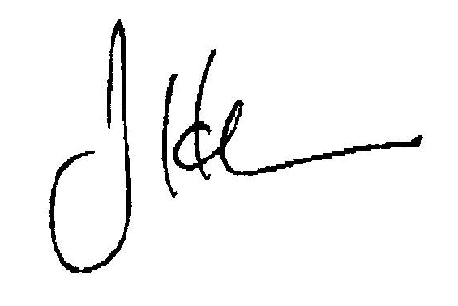

J H Carr
Clerk of the Council 7th September 2018

¹ A resolution will be tabled under s.1(2) of the Public Bodies (Admission to Meetings) Act (1960) to exclude the public from this part of the meeting on the grounds that publicity would be prejudicial to the public interest by reason of the confidential nature of the business to be transacted and the additional requirements for confidentiality imposed by various extant Acts of Parliament.

